Arria’s Guide to Roman Garb
In the first few centuries there were typically 3 types of clothing that Roman women wore.
They are:
- the gap sleeved tunic
- the tunica
- the peplos
The width of the tunic is determined by the arm span of the wearer. Standing straight with your arms out to your sides, measure the length from elbow to elbow. Add seam allowance and voila! The length depends on the type of tunic. The gap sleeved tunic, tunica and dalmatic tunics all figure their length from the wearer’s nape to the ground. Again add seam allowance and done. The peplos requires an extra step. Take the length and add a minimum of 10 inches for the overhang.
Gap Sleeve Tunic
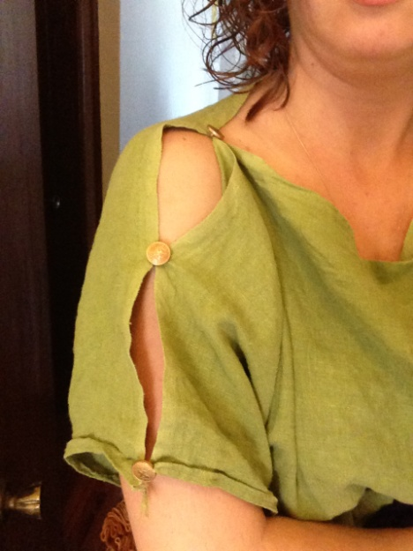
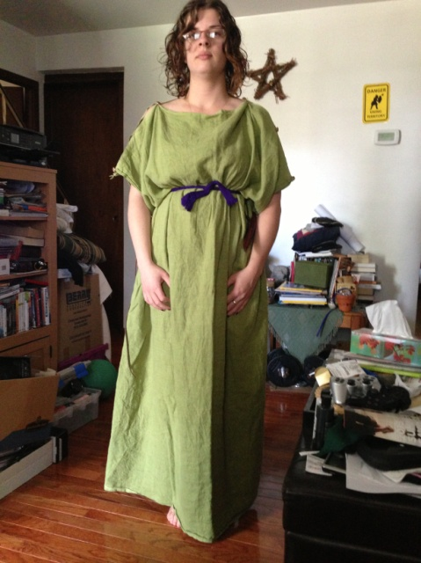
The gap sleeved tunic was popular in the first and second centuries. It is a style which was “borrowed” from the Greeks. These tunics, like most others were made with wool, linen and occasionally for the very wealthy with silk. Silk was only worn by women.
The sleeves on this tunic are created by the overhang from the width of the top of the tunic. It is called a gap sleeved tunic because of the way the top of the tunic is held together. This tunic is closed with a series of clasps. There is debate in whether these clasps are pins or buttons or knots. These clasps are spaced at equal distances up the arm. They usually stop approximately an inch from the end of the “sleeve”. I believe this allows for some extra mobility when wearing the tunic.
The tops and bottoms of the tunics are sewn as straight seams, unless like me you can use the selvages as the hems. Here is a photo of the sleeves, clearly showing the gaps created by the

Tunica
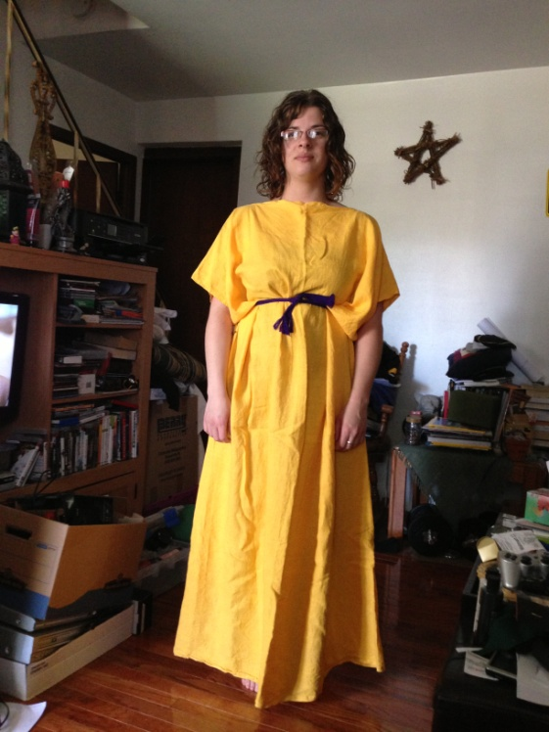
The tunica was popular in the late second century. It looks very similar to a man’s tunic, except for the length. Roman women covered themselves in public to be considered proper, so their tunics came down to the ground to cover most of their feet.
This is the simplest of the tunics to create. It is quite literally 2 rectangles sew together. Make sure to leave space for your arms, and your head. I recommend measuring around your elbow while it is bent and added 2 inches minimum for ease.
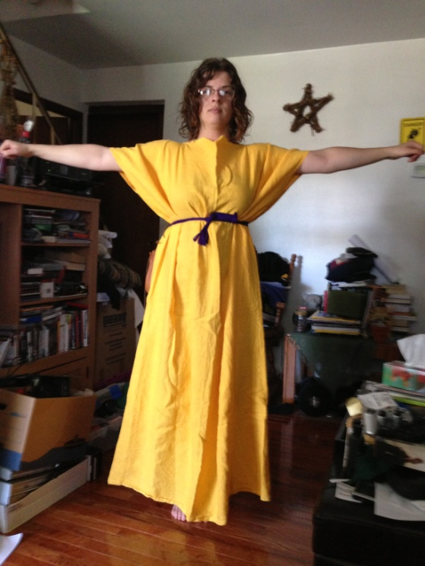
For your head, do not attempt to round the neckline at all. Leave it as a straight line. To create ease in the neckline, make sure your front triangle is a few inches wider than your back. This creates a draping effect in the neckline and keeps you from choking yourself.
The sleeves on this tunic are again created by the overhang from the width of the tunic. The shoulder seam on this tunic is a solid, straight seam.
Decorations for this tunic are fairly simple. Two lines of trim or coloured linen can be sewn down the front and back of the tunic vertically, equidistant from the edges. I suggest placing the trim approximately an inch from the starting and ending points of the neckline.
You can also add a band of coloured linen to the bottom of this tunic. These bands were sometimes decorated, and other times left plain. Embroidery, though not common, was found in Roman times. Usually if there was a pattern on a garment it was woven directly into the garment itself. Appliqué was not unknown in Roman times either.

Peplos
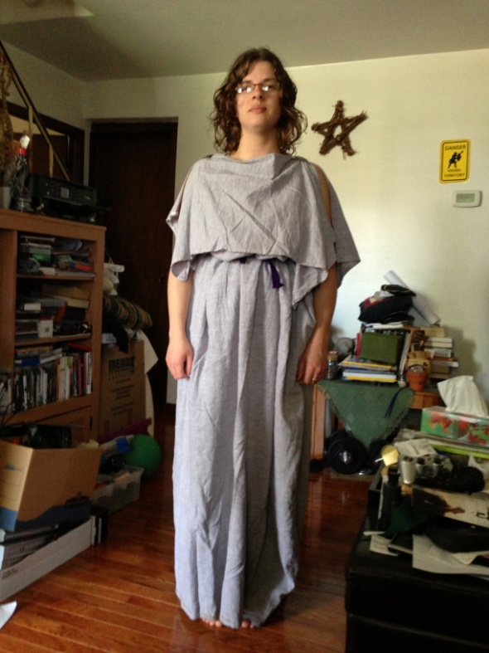
The peplos is another style of tunic which the Romans borrowed from the Greeks. This tunic has a overhang from its long length. It is fastened at the shoulders by two clasps called fibula. These fibulae (plural form) can be found in many different shapes and sizes, so find something you like and go with it.
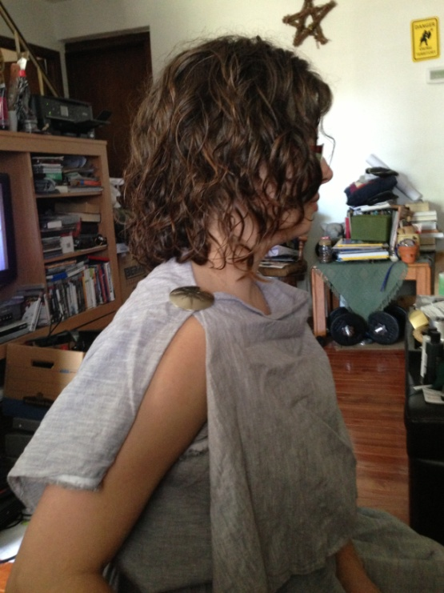
To create this type of tunic it is recommended that your overhang be at least 10 inches long. While cutting your fabric you decide you want a longer overhang or a shorter one that is fine as well. A word of caution- if you are planning an overhang which is noticeably longer then where your belt sits, be sure to tie your belt over the flap. It was not uncommon for these overhangs to be hip length. I believe this was done for two reasons. The first, it is a chance to show off how rich you are that you can afford so much excess fabric. The second, the Roman’s favoured pear shaped women, and the excess fabric at the hips would help emphasize that shape.
To create this type of tunic you will need your shoulder to floor measurement as well as your elbow to elbow measurement.
Using the shoulder to floor measurement add the length of the overhang you would like. For example my shoulder to floor measurement is 56 inches. I like my overhang to be 10 inches so 56+10= 66 inches. Add seam allowance and this is your length for the tunic.
When sewing the tunic make sure to sew the side seams approximately to your shoulder to floor measurement. I believe I sewed mine to around 53 inches to leave from for my arms. Make sure to finish the hems on your overhang so they do not fray. Then while wearing the tunica have a friend fold the overhang and hold the top until it is in a comfortable position. Pin both the front and back of the tunic together.
Decorations on this tunic can be places on the overhang itself. You can place trim on the edges of the overhang. Remember that what you do to the front of the tunic do to the back. The Romans liked symmetry.

Accessories
Roman Matronas (married Roman women) in the first century and the first part of the second century wore a outer garment called a stola. This garment is the female status equivalent of the man’s toga. {TANGENT: Only at the beginning of the first century did females wear the toga, after that time respectable women wore a tunic a stola (if they were married), and a palla in public, only prostitutes wore togas.}
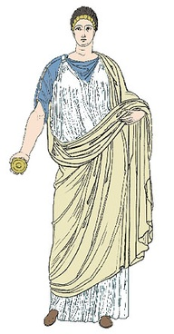
The stola was worn by respectable roman women. It was a garment which was the same width as the tunics but the neckline was treated differently. The stola has straps, where the other garments do not.
The stola also has a v-shaped neck. This is to show the tunic underneath of the stola. The stola is sleeveless. It is longer than the tunica underneath, so they the woman’s shoes are barely visible. The stola was made of a different colour then the tunic worn underneath it. It was worn with the gap sleeved tunic and tunica.
Roman women of any age also wore a palla while out in public. It was wrapped around the body and could be pulled up over the head to be used as a veil. Pallas had to be several meters long as they needed to be wrapped around the body.

Here are some websites that I found helpful:
http://www.unrv.com/culture/ancient-roman-clothing.php
http://www.roman-empire.net/society/soc-dress.html

